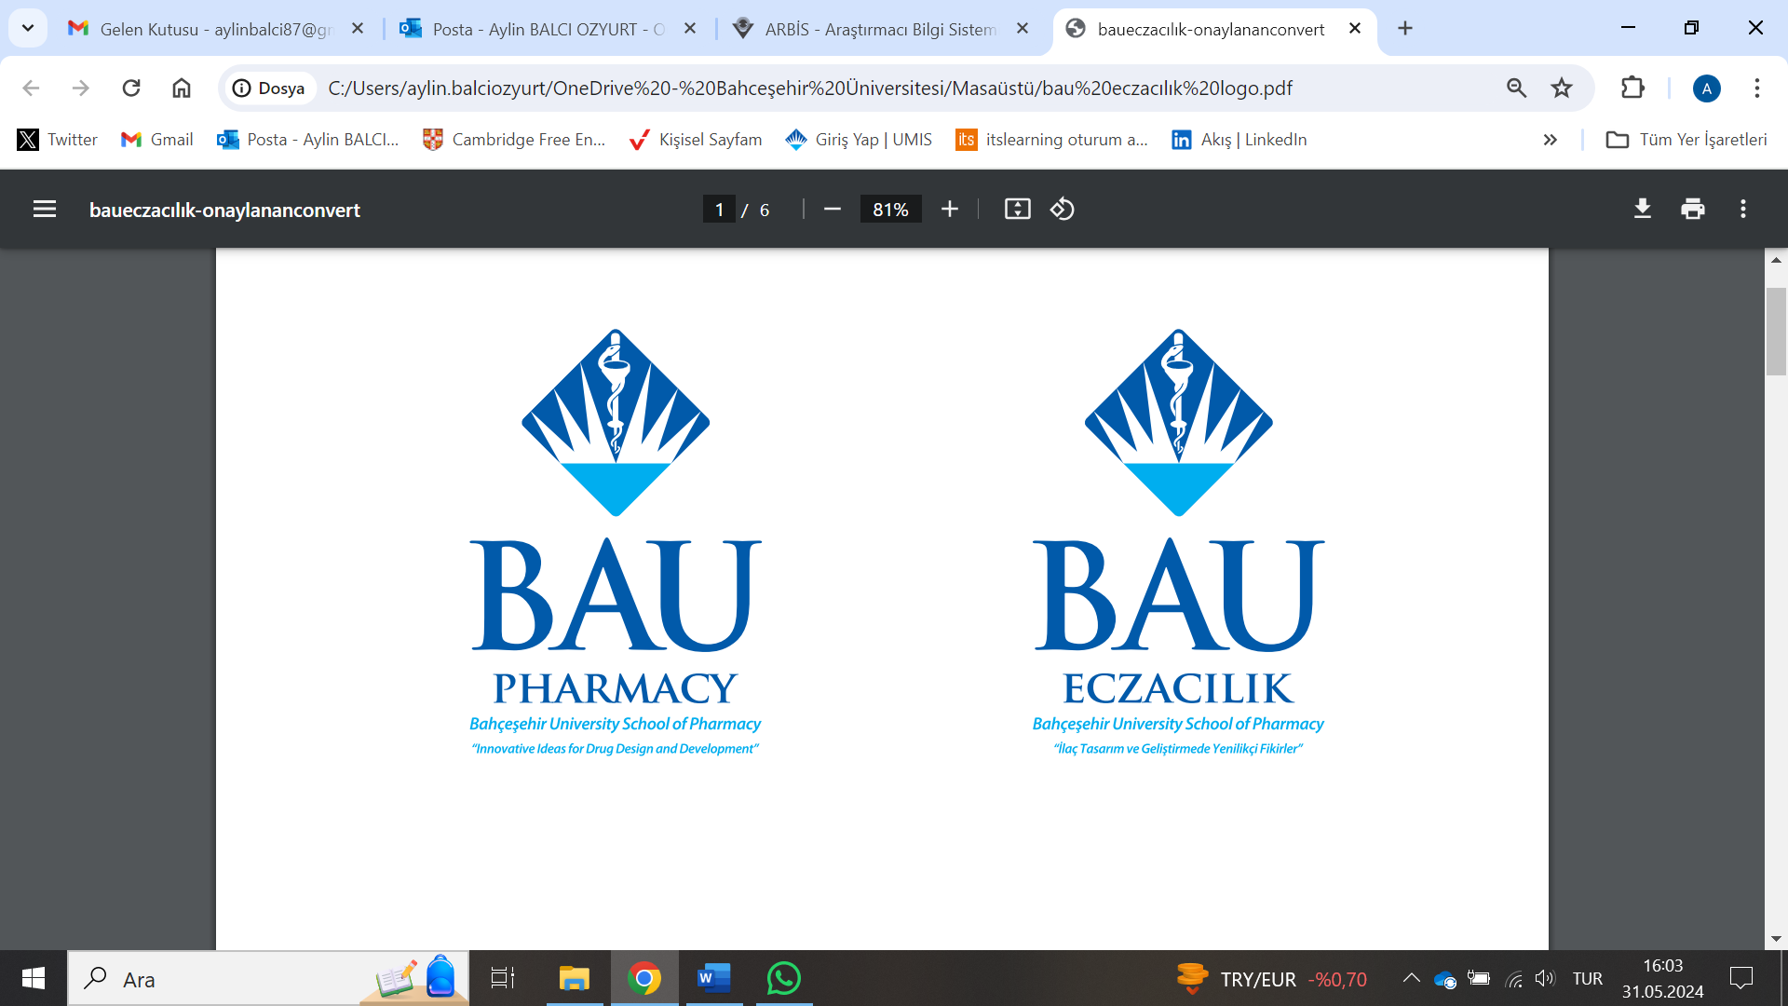

Photo

REPUBLIC OF TURKIYE

BAHÇEŞEHİR UNIVERSITY

SCHOOL OF PHARMACY

INTERNSHIP NOTEBOOK
PHAR 4999 INTERNSHIP-II

- Work reports must be filed daily throughout the duration of the internship per the attached report format.
- Work reports must be signed and stamped daily by the supervising pharmacist.
- At the end of the internship period, the Internship Benchmark Report must be filed by the intern and approved (via stamp and signature) by the supervising pharmacist.
- All reports must be completed digitally and only printed for signing and stamping. Please do not deliver hand-written reports.
- Disciplinary action will be taken for students who are found to have plagiarized, AI-generated, purchased third party services, or otherwise engaged in unethical conduct to write their report forms.
- At the end of the internship period, an Internship Evaluation Form must be completed by the supervising pharmacist and delivered by hand to the department secretariat in a sealed envelope.
- Deadlines for internship reports and evaluation forms will be announced by the department during the Fall semester. The final documents that must be submitted are as follows:
  - The student internship report, containing daily Work Reports and the Internship Benchmark Report bound together as a single book.
  - The Internship Evaluation Form, to be filed and delivered in a sealed envelope by the supervising pharmacist.

REPUBLIC OF TURKIYE

BAHÇEŞEHİR UNIVERSITY

SCHOOL OF PHARMACY

COMMUNITY PHARMACY
INTERNSHIP-II REPORT

NAME:
STUDENT NO:
SIGNATURE (INTERN):
SUPERVISING PHARMACY:
INTERNSHIP START AND END DATE:
INTERNSHIP DURATION (TOTAL WORK DAYS):
STAMP AND SIGNATURE (SUPERVISING PHARMACIST):

*Every page of the report, including the cover, must be signed and stamped individually

DAILY REPORT
Date:
Working Hours:
Daily Practices and Outcomes:

*

*

*

Daily Approval of the Responsible Pharmacist

DAILY REPORT
Date:
Working Hours:
Daily Practices and Outcomes:

*

*

*

*

Daily Approval of the Responsible Pharmacist

DAILY REPORT
Date:
Working Hours:
Daily Practices and Outcomes:

*

*

*

*

Daily Approval of the Responsible Pharmacist

DAILY REPORT
Date:
Working Hours:
Daily Practices and Outcomes:

*

*

*

*

Daily Approval of the Responsible Pharmacist

DAILY REPORT
Date:
Working Hours:
Daily Practices and Outcomes:

*

*

*

*

Daily Approval of the Responsible Pharmacist

DAILY REPORT
Date:
Working Hours:
Daily Practices and Outcomes:

*

*

*

*

Daily Approval of the Responsible Pharmacist

DAILY REPORT
Date:
Working Hours:
Daily Practices and Outcomes:

*

*

*

*

Daily Approval of the Responsible Pharmacist
DAILY REPORT
Date:
Working Hours:
Daily Practices and Outcomes:

*

*

*

*

Daily Approval of the Responsible Pharmacist

DAILY REPORT
Date:
Working Hours:
Daily Practices and Outcomes:

*

*

*

*

Daily Approval of the Responsible Pharmacist

DAILY REPORT
Date:
Working Hours:
Daily Practices and Outcomes:

*

*

*

*

Daily Approval of the Responsible Pharmacist

DAILY REPORT
Date:
Working Hours:
Daily Practices and Outcomes:

*

*

*

*

Daily Approval of the Responsible Pharmacist

DAILY REPORT
Date:
Working Hours:
Daily Practices and Outcomes:

*

*

*

*

Daily Approval of the Responsible Pharmacist

DAILY REPORT
Date:
Working Hours:
Daily Practices and Outcomes:

*

*

*

*

Daily Approval of the Responsible Pharmacist

DAILY REPORT
Date:
Working Hours:
Daily Practices and Outcomes:

*

*

*

*

Daily Approval of the Responsible Pharmacist

DAILY REPORT
Date:
Working Hours:
Daily Practices and Outcomes:

*

*

*

*

Daily Approval of the Responsible Pharmacist

DAILY REPORT
Date:
Working Hours:
Daily Practices and Outcomes:

*

*

*

*

Daily Approval of the Responsible Pharmacist

DAILY REPORT
Date:
Working Hours:
Daily Practices and Outcomes:

*

*

*

*

Daily Approval of the Responsible Pharmacist

DAILY REPORT
Date:
Working Hours:
Daily Practices and Outcomes:

*

*

*

*

Daily Approval of the Responsible Pharmacist

DAILY REPORT
Date:
Working Hours:
Daily Practices and Outcomes:

*

*

*

*

Daily Approval of the Responsible Pharmacist

DAILY REPORT
Date:
Working Hours:
Daily Practices and Outcomes:

*

*

*

*

Daily Approval of the Responsible Pharmacist

DAILY REPORT
Date:
Working Hours:
Daily Practices and Outcomes:

*

*

*

*

Daily Approval of the Responsible Pharmacist

DAILY REPORT
Date:
Working Hours:
Daily Practices and Outcomes:

*

*

*

*

Daily Approval of the Responsible Pharmacist

DAILY REPORT
Date:
Working Hours:
Daily Practices and Outcomes:

*

*

*

*

Daily Approval of the Responsible Pharmacist

DAILY REPORT
Date:
Working Hours:
Daily Practices and Outcomes:

*

*

*

*

Daily Approval of the Responsible Pharmacist
DAILY REPORT
Date:
Working Hours:
Daily Practices and Outcomes:

*

*

*

*

Daily Approval of the Responsible Pharmacist

DAILY REPORT
Date:
Working Hours:
Daily Practices and Outcomes:

*

*

*

*

Daily Approval of the Responsible Pharmacist

DAILY REPORT
Date:
Working Hours:
Daily Practices and Outcomes:

*

*

*

*

Daily Approval of the Responsible Pharmacist

DAILY REPORT
Date:
Working Hours:
Daily Practices and Outcomes:

*

*

*

*

Daily Approval of the Responsible Pharmacist

DAILY REPORT
Date:
Working Hours:
Daily Practices and Outcomes:

*

*

*

*

Daily Approval of the Responsible Pharmacist

DAILY REPORT
Date:
Working Hours:
Daily Practices and Outcomes:

*

*

*

*

Daily Approval of the Responsible Pharmacist

BAHÇEŞEHİR UNIVERSITY
SCHOOL OF PHARMACY
PER THE FACULTY’S INTERNSHIP LEARNING BENCHMARKS, THE FOLLOWING TOPICS MUST BE DEFINED AND DESCRIBED IN THE INTERN’S FINAL REPORT
The sections below must be fully explained by the intern and approved (via stamp and signature) by the supervising pharmacist.
PHARM4999 INTERNSHIP II Community Pharmacy
- Provide information about hygiene conditions and the working environment in the pharmacy.
- Explain the medications that must be prescribed on special prescriptions (purple, orange, red, and green) and the procedures related to these prescriptions.
- Describe the procedures for dispensing and recording prescriptions containing narcotic and psychotropic drugs.
- Identify the medications for which the prescription must be retained in the pharmacy and explain the reasons.
- List the professional reference books required in the pharmacy (codex, pharmacopoeia, and formularies) and briefly explain their purposes.
- Describe the professional periodic scientific and/or professional publications, as well as electronic and online drug information sources available in the pharmacy.
- List the registers that must be kept in pharmacies.
- Explain the procedures for maintaining business, inventory, manufacturing, prescription, narcotics, inspection, and personnel registers.
- Explain the pharmacy’s accounting system, including the selection of an accountant, invoicing procedures, expense reporting, tax returns, insurance premium payments, and the relationship between the pharmacist and the accountant.

